PA4 Report

Chase Minden

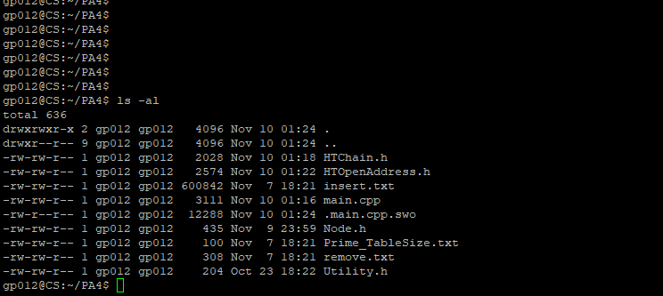



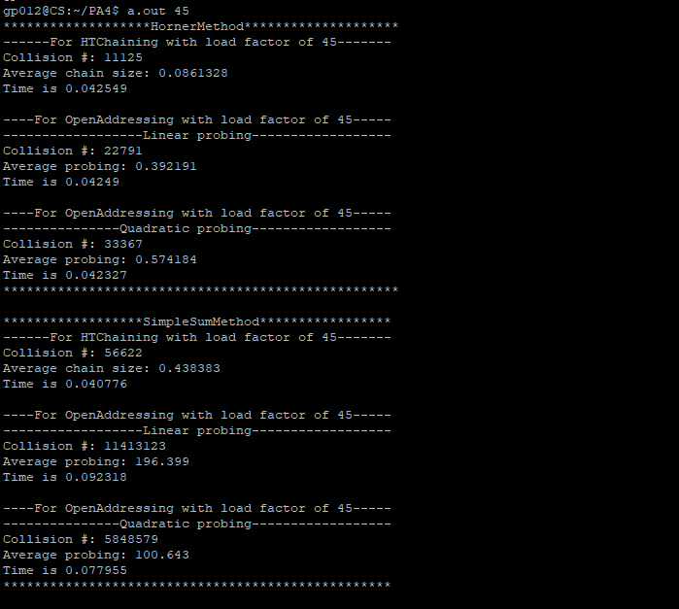

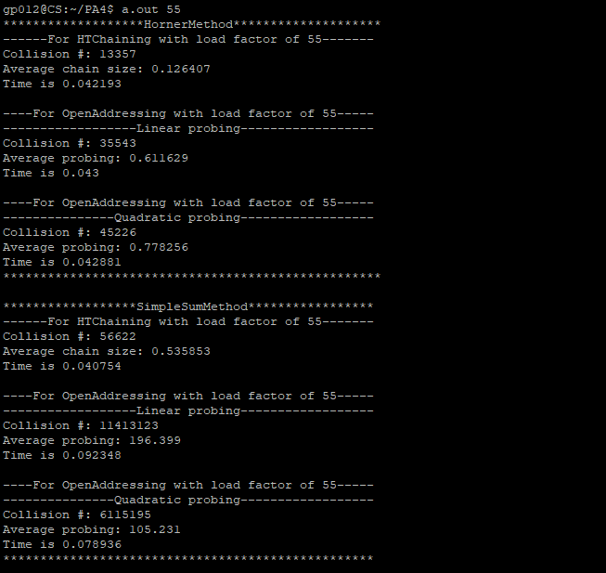

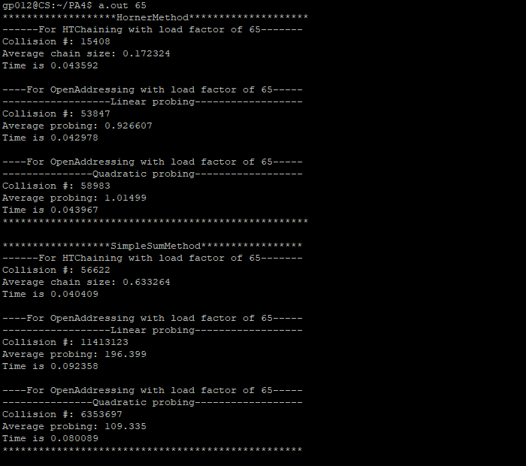

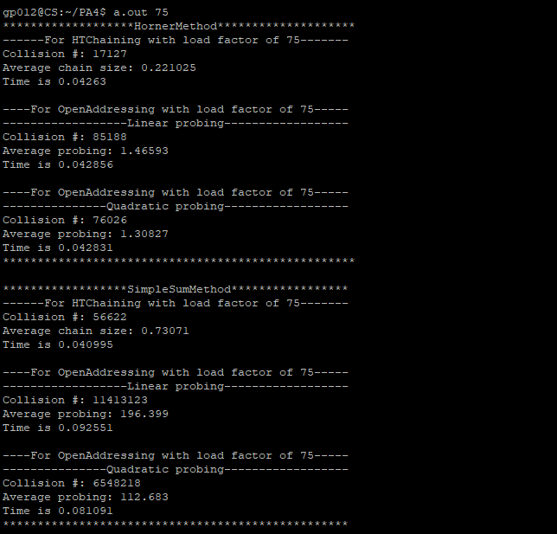

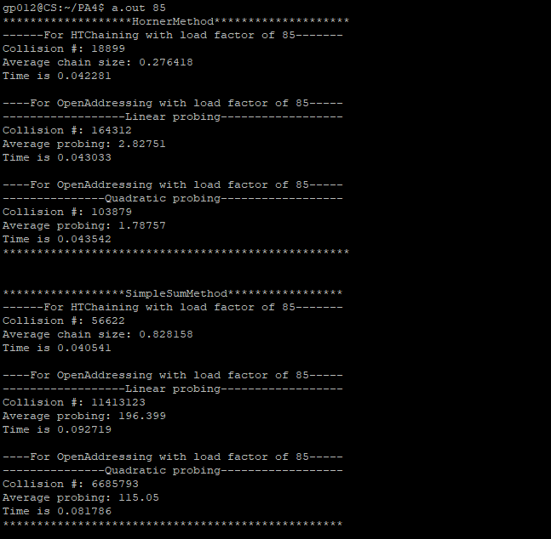

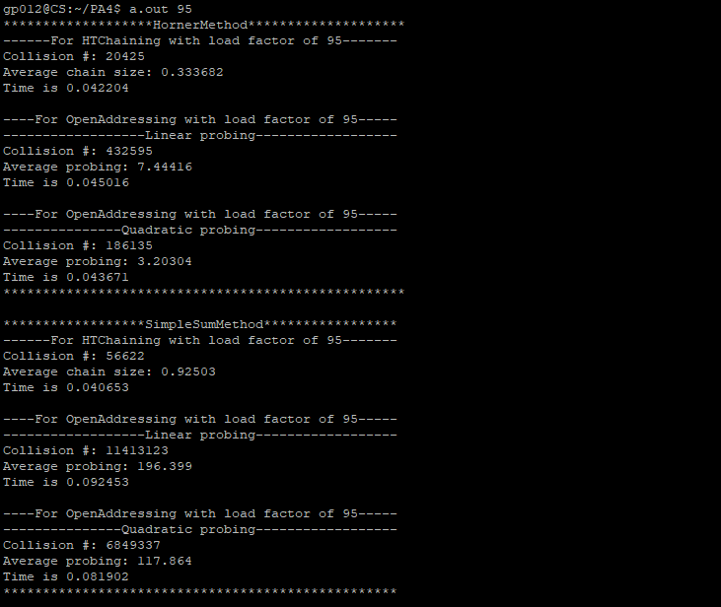

Observation:

1. The Horner has function performs better average with the different types of Hash tables
2. As the load factor went up, every single collision resolution technique encountered more collisions. The linear probing encountered this the worst.
3. Hash Tree Chaining performed the best, and the Hash Tree Linear Probing did the worst overall.
4. The average number of comparisons would be Log(N), with N being 58112, so about 4.7 comparisons
5. If you are wanting to search for data with insert or delete, then hash functions allow for a much faster search time, with O(1) possible search time